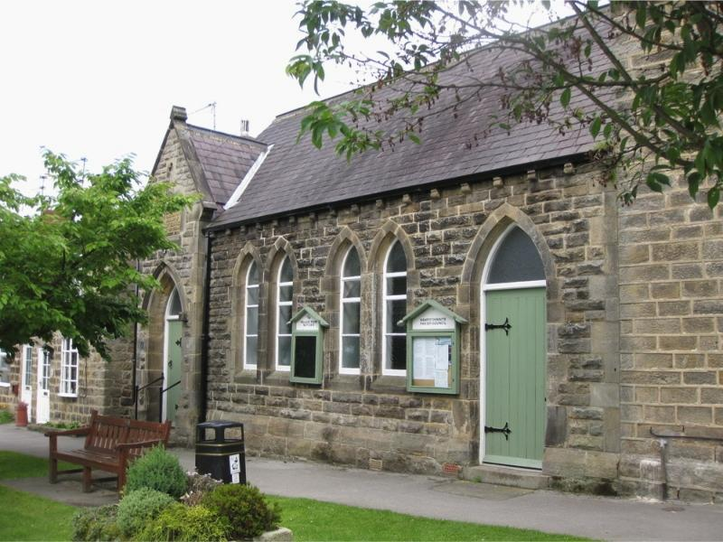
Hampsthwaite Village Room
High Street
Hampsthwaite, HG3 2ET

Bookings:
Email: villageroombookings@hampsthwaite.org.uk
Web: http://www.hampsthwaite.org.uk/villageroom/
Tel: 01423 770332

Village Room COVID Risk Assessment– Guidance for Hirers

This guidance shows the kind of approach groups might take when hiring the Village Room. Use it as a guide to think through some of the hazards and the steps you need to take to control the risks which are particular to your group. Please note that it is not a generic Risk Assessment that you can just put your group name on and adopt wholesale without any thought. This would not satisfy the law - and would not be effective in protecting people.

Area of Risk | Risk identified | Actions to take to mitigate risk | Notes
Cleanliness of hall and equipment, especially after other hires | Other hirers or hall cleaner have not cleaned hall or equipment used to standard required. One group leaves hall or equipment without cleaning. | Group organiser to check when room is cleaned.  Ensure regularly used surfaces are cleaned before, during and after hire e.g. tables, sinks, washbasins, door handles, WC seats and locks. | Bring your own equipment as far as is possible and ensure it has been cleaned.  Report any problems to the Booking Secretary
Managing Social distancing and especially people attending who may be vulnerable | People do not maintain social distancing | Advise group they must comply with social distancing as far as possible including while waiting to enter the premises and when using more confined areas (e.g. moving and stowing equipment, which should be kept as brief as possible).  Adopt layouts to facilitate this – eg position furniture as far as possible to facilitate people seating side by side, with at least one empty chair between each person, rather than face to face, and if tables are being used, they should be placed to maintain a distance of at least 2 metres across between people who are face to face (e.g. using a wide U-shape).  Organise in ‘support bubbles’ or ‘household groups’ where possible. | Ensure only one user at a time is in the toilets and that there is no queueing in the toilets area  Take particular care to ensure 2m Social distancing with any persons aged 70 or over or likely to be clinically more vulnerable to COVID-19  Ask people to bring their own food and drink?  For performances and other events with seated audiences, it is recommended that attendants be provided, who will ask people to seat themselves furthest from the entrance on arrival and to leave closest to the exits first.
Respiratory hygiene | Transmission to other members of group | Catch It, Bin It, Kill It.  Provide tissues and ask all to dispose into a bin or disposable rubbish bag, then wash or sanitise hands.  Encourage group to avoid touching mouth, eyes, and nose.  Face coverings are most relevant for short periods indoors in crowded areas where social distancing isn’t possible.  Face coverings do not replace social distancing. | You may wish to ensure you bring your own tissues and hand sanitiser.  Empty bins and dispose at end of hire.  Open windows and doors for ventilation when possible and ensure they are closed afterwards  Face coverings are advised when working with food or vulnerable people.  The priority is that social distancing and good hygiene are maintained.
Hand cleanliness | Transmission to other members of group and premises | Advise group to use sanitiser on entering and exiting, to wash hands regularly using soap and paper towels. | Avoid sharing equipment as far as possible  Allow time for this at the start and end of each session
Someone falls ill with COVID-19 symptoms | Transmission to other members of group and premises | Keep a register, identify contacts, inform Booking Secretary. Follow instructions. Ensure they leave and seek medical attention or move person to safe area. | If unable or unsafe to return home, transfer to Isolation Area located in kitchen area then call for medical assistance. Use PPE provided there.

Village Room COVID Risk Assessment Template – Hirers (DRAFT)

Group/Organisation name:

Assessment carried out by: Date assessment was carried out:

All groups, organisations or societies hiring the Village Room must protect its members from harm. This includes taking reasonable steps not only to protect them, but also other groups which may follow, from coronavirus. This is called a COVID-19 risk assessment and it will help us all manage risk and protect people visiting the Village Room.

Every Group is different - you need to think through the hazards and controls required in your Group for yourself – eg in terms of the particular membership, activities, equipment or spaces used.

Keep a register of group members’ phone numbers and/or email addresses to facilitate contact tracing. Ensure all know why you have the data, keep it secure and erase when no longer needed – see http://www.hampsthwaite.org.uk/memorialhall/548 for further information on Data Protection (GDPR).
.
This Template can be used to help ensure the key areas required by the Village Room Risk Assessment and Special Conditions of Hire have been covered – see http://www.hampsthwaite.org.uk/villageroom/750 . Extend on to other pages if needed.

Once completed, the Actions listed in the Risk Assessment will need to be monitored to ensure that what has been put in place is working as expected.

Area of Risk | Risk identified | Actions to take to mitigate risk | Notes
Village Room and Equipment Cleanliness

Social Distancing

Respiratory Hygiene

Hand Cleanliness

Someone falls ill with COVID-19 symptoms

