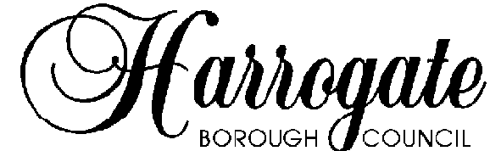

Working for you

Mr C Moore  Clerk To Hampsthwaite P C  83 The Whartons  Otley  W Yorkshire  LS21 1BS | Our Ref: | DCPARISH 6.92.249.B.FUL 17/02746/FUL
 | Your Ref:
 | Date: | 12 September 2017

PARISH COUNCIL NOTIFICATION - PLEASE RETURN NOT LATER THAN 3 October 2017

APPLICATION TYPE: Full permission
APPLICATION NO: 6.92.249.B.FUL 17/02746/FUL
PROPOSAL: Erection of single storey, two storey, first floor and dormer extensions, replacement roof, chimneys and detached garage, rendering of elevations, conversion of loft to form additional living accommodation, alterations to fenestration and formation of terrace.
LOCATION: 22 Hollins Close Hampsthwaite HG3 2EH
GRID REF: E 426272 N 458672
APPLICANT: Mr And Mrs Peters

http://uniformonline.harrogate.gov.uk/online-applications/applicationDetails.do?activeTab=summary&keyVal=ORSYJWHYLV700

Guidance on using pdf measuring tools is available on our website.

Please be aware that in a small minority of cases some documents will only be available 24 hours after the issue of this letter, therefore please do not formulate your response until you have been able to access all the information.

If you require any further information or assistance about this particular application please contact the Case Officer whose name can be found on Public Access within 3 working days of this letter. Please email using the convention firstname.lastname@harrogate.gov.uk.

Please CIRCLE A, B, C or D as appropriate. Write your comments overleaf and number each comment.

A The Parish Council has no objections.

B The Parish Council objects on the planning grounds set out overleaf.

C The Parish Council does not object to or support the application but wishes to make comments or seek safeguards as set out overleaf.

D The Parish Council supports the application.

Date of Response ......................................
There is no need to sign this consultation response.
Do not send the views of individual Parish Councillors, either as a list of (possibly conflicting) points or as a batch of separate letters. The Parish Council must form a corporate view.

